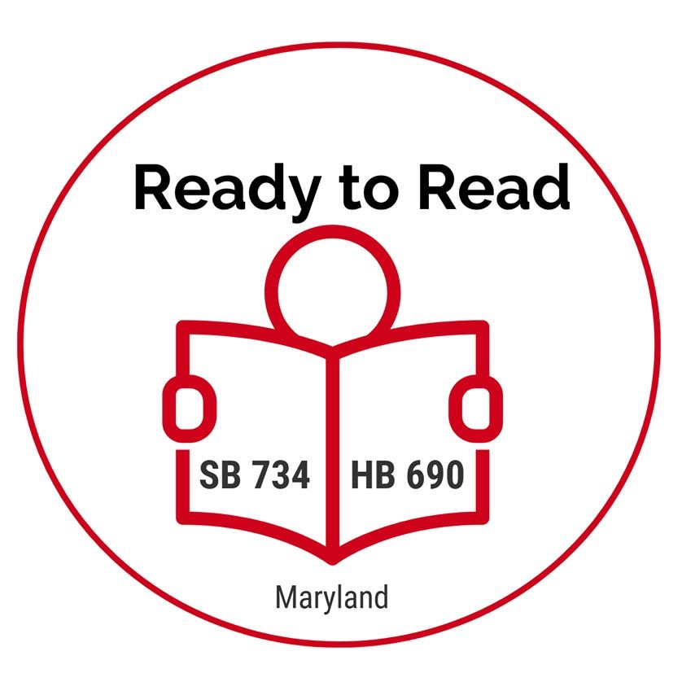

DATE

Senator or Delegate Last NAME
Room number
Maryland General Assembly
Annapolis, MD 21401

Re: Support for the Ready to Read Act of 2019: Senate Bill 734 and House Bill 690

Dear Senator or Delegate LAST NAME:

I am writing to seek your support for The Ready to Read Act of 2019 (SB734 / HB690) sponsored by Senator Craig Zucker and Delegate Eric Luedtke. The Ready to Read Act would require local Boards of Education to implement a preventative reading screening and intervention framework for all pre-kindergarten, kindergarten and first grade students. The Act uses a prevention model to find students who are likely to struggle with reading, because once once poor reading trajectories are established, they are difficult to change.
As a INSERT PARENT OR EDUCATOR of a struggling reader, this bill is important to me personally because Give a 2-3 sentence personal story sharing how late identification of your child or students’ reading struggles impacted you (if applicable). Include how early screening could change a student’s reading outcomes or other information about how you are seeing good outcomes using reading screening in your classroom.
Maryland’s reading scores are concerning. According to recent data from the National Assessment for Educational Progress (NAEP) and standardized Maryland reading data, only 43% of Maryland’s fourth graders are proficient in reading. This means 57% of all Maryland fourth graders, at the age of 10, are left without the basic reading skills needed to become “college and career ready.”

The Ready to Read Act is part of an early warning system designed to eliminate or reduce costly efforts to address reading gaps after a student has fallen behind. Research shows that reading difficulties can be remediated with less difficulty, time and expense when addressed early. Remediating a fourth grade student can take two hours of intervention while a Kindergarten student needs a thirty minute intervention to achieve the same outcome. The Ready to Read Act will call on school districts to determine who may struggle before they fall behind and provide evidence based reading instruction as early as possible within an integrated, tiered system of supports (ITSS, includes Response to Intervention/Instruction).,

Students who are disproportionately impacted by Maryland’s lack of an early warning system include English language learners, minority groups, special education students, and students who experience poverty at home or in the community. Reading performance data, combined with the number of students required to take remedial English coursework before admission to community college in Maryland, underscores why we must focus resources on students as early as possible to prevent reading failure and prevent poor academic and mental health outcomes.

In closing, the Ready to Read Act will help students receive effective core instruction and supplementary interventions at a time when it will have the most impact and require the fewest resources. The bill is aligned to federal, state and local requirements for reading and literacy education. I am asking for your support for this bill. We cannot continue to leave more than 50% of Maryland’s students without access to college and career opportunities.

Thank you for your consideration of my request. Please contact me if you have concerns or questions or if you would like additional information.

Sincerely,

Your Name
Your Address
Your City, State & Zip
Your Phone number, Your email

CC: Decoding Dyslexia MD, via email: decodingdyslexiamd@gmail.com
Chairman Paul Pinsky, paul.pinsky@senate.state.md.us
Chairman Anne Kaiser, anne.kaiser@house.state.md.us

Ready to Read Act Coalition, Contact Information
Janice Lepore, Psy.D. and State Leader, Decoding Dyslexia MD (DDMD) janice_lepore@verizon.net
Audrey Potter, Legislative Chair, Maryland School Psychologists’ Association, legislative@mspaonline.org
Laura Schultz, DDMD State Leader, MD Dyslexia Task Force Member, 703-477-4847, decodingdyslexiamd@gmail.com
Amy Siracusano, Board Member, The Reading League, MD Dyslexia Task Force, MD Educator, amysiracusano@me.com
Karleen Spitulnik, State Leader, Decoding Dyslexia Maryland (DDMD), 443-850-6493 k.spitulnik@verizon.net
Robin Szymanski, DDMD, MD Dyslexia Task Force Member, Maryland Educator, 18happyelephants@gmail.com

See Transitional Supplemental Instruction, Working Group 3, Element 3c, Commission on Innovation & Excellence in Education, Kirwan Commission.
Orton-Gillingham Classroom Educator Level (OGCE) Training for Maryland State Department of Education/Juvenile Services Education System (MSDE/JSES) Request for Quotation
Dr. Joseph Torgesen, 2004, 2007
Curriculum, Instruction and Assessment, Maryland Department of Education, p. 6-8, pp. 13, 16
Every Student Succeeds Act (ESSA), Literacy Education for All, Sec. 2221
Reading Outcomes by Subgroup, Maryland 4th Grade Students (PARCC 2018)
Remedial Coursework in Maryland Community Colleges, 9.2018, MLDS
MCCRS, Appendix A, ESSA (LEARN Act), ESSA Title I and Title II, Maryland Comprehensive Literacy Plan

